Modeling Human Brain Activity
in Secretary Problem
Noam Ishay¹, Dor Mizrahi¹, Ilan Laufer¹, and Inon Zuckerman¹
¹ Department of Industrial Engineering and Management, Ariel University, Ariel, Israel
Noam.isahy@msmail.ariel.ac.il
{dor.mizrahi1,ilanl,inonzu}@ariel.ac.il
Abstract. The secretary problem is a decision-making problem, deals with bos that must choose the best secretary from N secretaries under a number of assumptions that limit his choices, in our research we use the idea that the problem brings with it in order to check whether it is possible to detect a change in the EEG signals that express the activity The cerebral tram, indicating a situation in which he makes a decision due to his decision to "choose a secretary."
Keywords: Decision Making • EEG • ERP•Mne
- Introduction
The Secretary Problem deals with an employer who is looking for a secretary and wants to choose the best candidate among those who have applied. The employer interviews the candidates one by one in a random order and after each interview, he must decide whether to hire the current candidate or move on to the next one. At the time of the decision, the employer can rank the candidates that have been seen so far, but he cannot compare them to a candidate who has not yet been seen. If the employer decides not to hire the current candidate, she will move on to another opportunity and will not agree to accept the position even if the employer later changes his mind and offers it again. Therefore, immediately after an interview with each candidate, the employer must make a final decision to hire or reject the candidate. According to the problem's conditions, if no candidate was hired before the last candidate, the last candidate will be automatically selected [1,2].
The study examines whether it is possible to identify changes in EEG signals that express the electrical activity in the brain, indicating a situation in which a decision-maker is ready to make a decision to "choose a secretary".
- Research hypotheses
There is a difference in brain activity before and after the point of decision maturity that can be diagnosed as part of the decision-making process.
There is a correlation between the mathematical solution of the classical Secretary Problem (1/e) and the stage at which the brain is prepared to make a decision [1].
There is a difference in brain activity during decision-making when distinguishing between acceptance and rejection.

- Materials and Methods
The EEG data acquisition process during the experiment was recorded using a 16-channel g.USBAMP biosignal amplifier (g.tec, Austria) at a sampling frequency of 512Hz. 16 active electrodes were used to collect EEG signals from the scalp according to the international 10-20 system. The recording was done using the OpenVibe recording software, and the impedance of all electrodes was kept below a threshold of 5K ohms throughout the recording sessions [4,5].
We conducted the study by examining how the experimenters dealt with a "decision dilemma" similar to the Secretary Problem, where the experimenters faced a dilemma in order to maximize their profit by making a decision that, in their opinion, is the best, but not necessarily the optimal one [2].
In each round, the experimenter received a predetermined quantity (20) of quotes [2] for an apartment that he tried to sell (Fig.2 (a)), and for each quote, the experimenter had to decide whether to accept or reject it while trying to maximize the value received. If he rejected the quote, he could not choose it again, and if he accepted the quote, he could not see what he lost. If the experimenter did not receive any quotes before the final quote (20th quote), he was forced to accept the final quote regardless of its value.
To ensure validity and reliability, each experimenter saw the same values and in the same order, so that the position of the best quote was constant for all contestants.
All experimenters received identical instructions on how to conduct the experiment, as can be seen in the Hebrew language in Fig.1, we told them that the best choice in relation to the other contestants would yield a greater incentive in the range of 50 to 150 NIS, even though the yield was set arbitrarily.
Between quotes, a plus screen was displayed for a random period of time ranging between 200 and 250 milliseconds to avoid situations in which the experimenter expects an offer (Fig.2 (b)).


Fig.1. The app's splash screen with the instructions for the experimenter


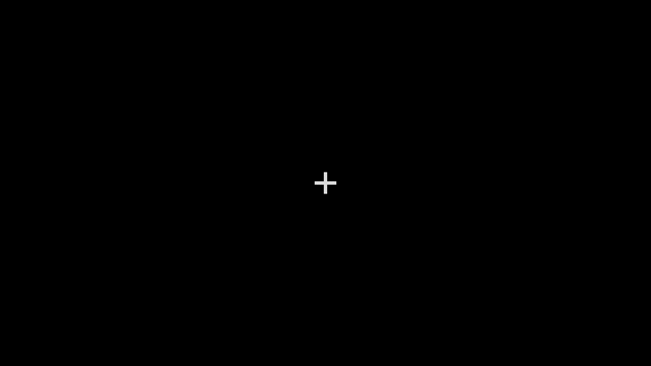
{a} {b}
Fig.2. (a) Stand by screen (b) quotes

The participants were 27 students from Ariel University who were enrolled in one of the courses on campus. We recorded one of the experimenters due to a technical failure of the system.
- Data Processing & Analysis
The data preprocessing was conducted in several stages, each stage focusing on cleaning a different type of noise, such as physiological sources (muscles, blinks, pulse, and breathing) and non-physiological sources (noise generated by the movement of electrodes relative to the scalp, movement of electrode wires, and environmental electromagnetic noise), and preparing the data for analysis. A band-pass filter was utilized to reduce the signal strength at frequencies above and below the frequency range that a person can produce (1-30 Hz).
Independent component analysis (ICA) was used to reveal the basic statistical sources of mixed signals, by decomposing the components, it was possible to identify signals that were not the result of making a choice, such as blinking and heart palpitations.
For each experimenter, we decomposed the signals into 16 components and attempted to identify the source of the signal by the topography schema of the head, which shows the signal strength and its origin, to understand the source of the noise and whether the signals were relevant for analysis or not, the process was carried out for each individual experimenter manually.
Baseline Correction was performed to reduce the impact of data drift, such as internal system inhibitions. Essentially, it involved "normalizing the data", and consisted of using the EEG activity over a base period (reference period), that is, before an external event occurs, to correct the activity over the stimulus time interval.
From the moment the proposal appears until the decision is made, baseline correction took for each epochs U [0.2,0.8] Sec before the choice occurred.
For each sample of the signal, we divided and made an average for the sample. We averaged the 16 channels into 4 areas (right front, left front, right rear and left rear) of the experimenter's head.
ERP (Events-Related Potential) reflects the potential (electrical signal) associated with an event, such as the appearance of a target (quote).
The components of the excitatory potentials are external manifestations of intracerebral processes and are calculated by the performance of the brain response to external events or by the time between the event and the appearance of the absolute latency during the performance of a task.
Absolute latency is the time interval between the presentation of the stimulus and the maximum value point (peak) of the EEG signals. It manifests itself in milliseconds and represents the time from the moment the decision is made by the Experimenter to the moment of selection (trigger).
Normalization of the time between the appearance of the peak signal and the event (quote) since there is a difference between humans (experimenters in our case). We calculated for each experimenter the average time (average absolute latency) for all his decisions and for the entire time interval from the peak to the appearance of the event, we divided it by the same average so that we created the relative time interval of the experimenter.
For each brain region (right front, left front, right rear and left rear) that we made an average for him we collected 3 samples from each experimenter in different time throughout the experiment and divided them into the following groups, for each group we gave a code name in python:
Start - the first group of decisions of the experimenters.
Median - the middle group of decisions of the experimenters before.
End - the group of recent decisions necessarily the acceptance of a proposal.
we performed paired samples t-tests and post hoc tests (Tukey) between the groups.
- Results
To evaluate the research hypotheses, we conducted several analyses on the processed data. Each analysis was designed to answer a specific hypothesis. We will discuss each hypothesis separately:
Hypothesis: There is a difference in brain activity before and after the time of brain maturity in the decision-making process.
Result: After conducting t-tests, we found that there is a significant difference in brain activity between the starting and median groups and the end group (in each electrode distribution group), however, the difference between the start and median groups is not statistically significant, as shown in Figures 3 and 4. This contradicts our research hypothesis, that suggesting a decision-making process can diagnosed through brain activity.
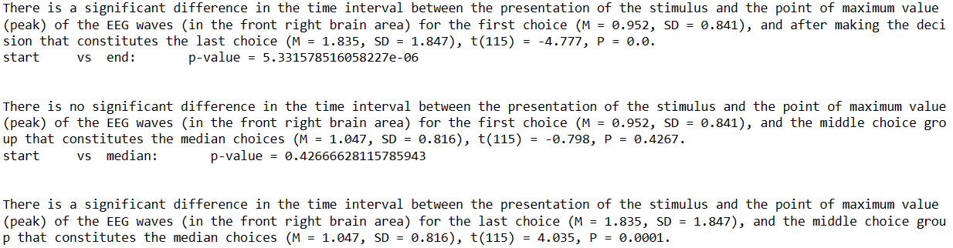
Fig.3. Front right brain area t-test

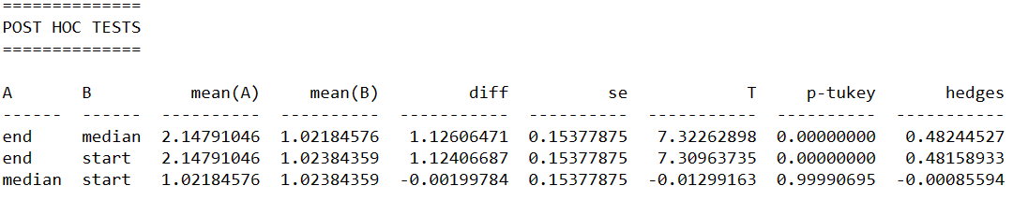
Fig.4. The pairwise tukey Test

Hypothesis: There is a correlation between the mathematical solution of the classical secretary problem (1/e) and the stage at which the brain is ready to make a decision.
Result: The calculations indicate that, on average, each participant viewed approximately 45% of the proposals prior to making a decision.
Hypothesis: There is a difference in brain activity in decision making while distinguishing between acceptance and rejection.
Result: According to Fig.5, it can be observed that there is indeed a statistically significant difference between the first two decision groups (start and middle) (rejection) and the last decision group (acceptance of the proposal). The difference is observed for each group compared to the last group.
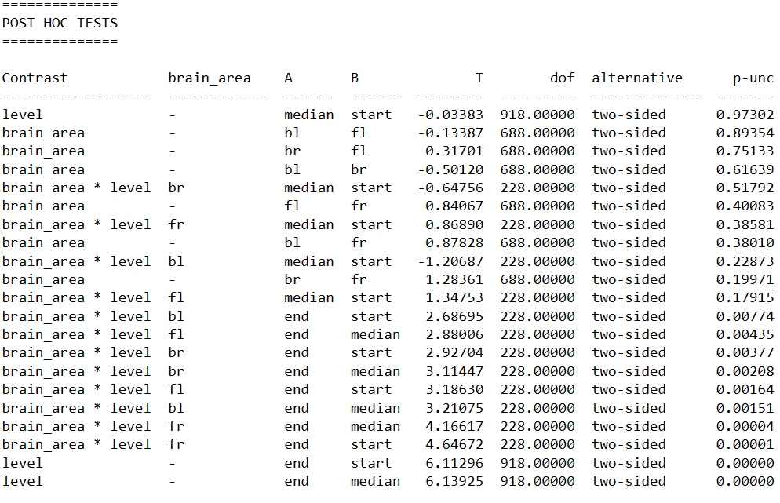
Fig.5. The pairwise t-tests, shows us significanceness only with the end group

- Discussion and Conclusions
The results of our study, as we analyzed them, did not provide evidence to support our initial hypothesis that there is a point in time at which the brain's activity changes during the decision-making process, this was determined through a comparison of three different decision points throughout the experiment, which showed no significant difference between the first and second-to-last decisions.
It can be inferred that brain activity is different when making a decision to accept or reject a proposal, suggesting that different neural processes may be at play in these situations, this conclusion is supported by the data from Fig.5, we found a statistical difference between acceptance and rejection decisions when comparing the time intervals between the moment of decision and the trigger.
In conclusion, while our initial hypothesis was not supported, we are pleased that we were able to achieve statistical significance and that our work was not in vain. An integral part of our success was the guidance and mentorship of academic lecturer Dr. Yinon Zuckerman, Dr. Dor Mizrahi, and Dr. Ilan Laufer, who assisted us throughout the project.

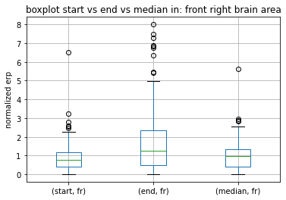
Appendices

Fig.5. Front right brain area boxplot

References
- Thomas, S.; Ferguson, A.; (Aug 1989); Who Solved the Secretary Problem? Institute of Mathematical Statistics: Statistical Science Vol. 4, No. 3, pp. 282289.
- Hsiao, C.; Kemp, S.; (2020); The effect of incentive structure on search in the secretary problem, Judgment and Decision Making, Vol. 15, No. 1, pp. 8292.
- Yajing, S.; Fali, L.; Duana, K.; Taoa, Q.; Cunbo, L.; Zehong, C.; Zhanga, Y.; Biswala, B.; Lig, P.; Yaoa, D.; (2019) Predicting individual decisionmaking responses based on singletrial EEG, NeuroImage Volume 206.
- Mizrahi, D.; Laufer, I.; Zuckerman, I.; (2021) Topographic Analysis of Cognitive Load in Tacit Coordination Games Based on Electrophysiological Measurements. In Proceedings of the NeuroIS Retreat, Virtual Conference, Vienna, Austria, 1–3 June 2021.
- "EEG>introduction";_http://www.medicine.mcgill.ca/physio/vlab/biomed_signals/EEG_n.htm; The McGill Physiology Virtual Lab.
- Neil Bearden, J.; Murphy Ryan, O.; Rapoport, A.; (October 2005) ; A multiattribute extension of the secretary problem: Theory and experiments; Journal of Mathematical Psychology; Volume 49, Issue 5, Pages 410422.
- Salma, N.; Mai, B.; Namuduri, K.; Mamun, R.; (17 November 2017); Using EEG Signal to Analyze IS Decision Making Cognitive Processes; Information Systems and Neuroscience pp 211–218
- GarcíaHern´andez, P.; Alejandra, F.; Cortes, P; HernándezGonzález, M.; SoteloTapia, C.; Angel Guevara, M.; (2021), Temporal division of the decisionmaking process An EEG study
- Si, Y.; Wu, X.; Li, F.; Zhang, L.; Duan, K.; Li, P.; Song, L.; Jiang, Y.; Zhang, T.; Zhang, Y.; Chen, J.; Gao, S.; Biswal, B.; Yao, D.; Xu. P.; (2019), Different DecisionMaking Responses Occupy Different Brain Networks for Information Processing: A Study Based on EEG and TMS, Cerebral Cortex, October 2019; 4119–4129.
- Hsiao, Y. C; (2018); An experimental investigation of the secretary problem: factors affecting sequential search behavior Authors.
- Alekseev, A.; Charness, G.; Gneezy, U.; (2017); Experimental methods: When and why contextual instructions are important, Journal of Economic Behavior & Organization, Volume 134, February 2017, Pages 4859.
- "Python Library for eeg: m.n.e", https://mne.tools/stable/index.html

